COMPUTER ASSIGNMENT

ADNAN KHAN

19BCY10051

B11+B12+B13

Q1. 1. Define a class student with the following specification

Private members of class student

admno                        integer

sname                        20 character

eng. math, science       float

total                            float

ctotal()                        a function to calculate eng + math + science with float return type.

Public member function of class student

Takedata()                   Function to accept values for admno, sname, eng, science and invoke

ctotal() to calculate total.

Showdata()                   Function to display all the data members on the screen.

Answer:

#include <iostream>

#include<conio.h>

#include<stdio.h>

#include<string.h>

using namespace std;

class Student

{

    int admno;

    float eng,mat,science;

    char sname[20];

    float ctotal()

    {

        float t;

        t=eng+mat+science;

        return t;

    }

    public:

        void takedata()

        {

            float total;

        cout<<"Enter admission number :- ";

        cin>>admno;

        cout<<"\nEnter student Name :- ";

        cin>>sname;

        cout<<"\nEnter marks of -\nEnglish";

        cin>>eng;

    cout<<"\nMaths";

        cin>>mat;

        cout<<"\nScience";

        cin>>science;

        total=ctotal();

        }

        void showdata()

        {

        cout<<"Admission number-"<<admno;

        cout<<"\nStudent Name-";

        puts(sname);

        cout<<"\nMarks of Subject -\n English-"<<eng;

        cout<<"\nMaths-"<<mat;

        cout<<"\nScience-"<<science;

        }

};

int main()

{

    Student s;

    s.takedata();

    s.showdata();

    getch();

return 0;

}

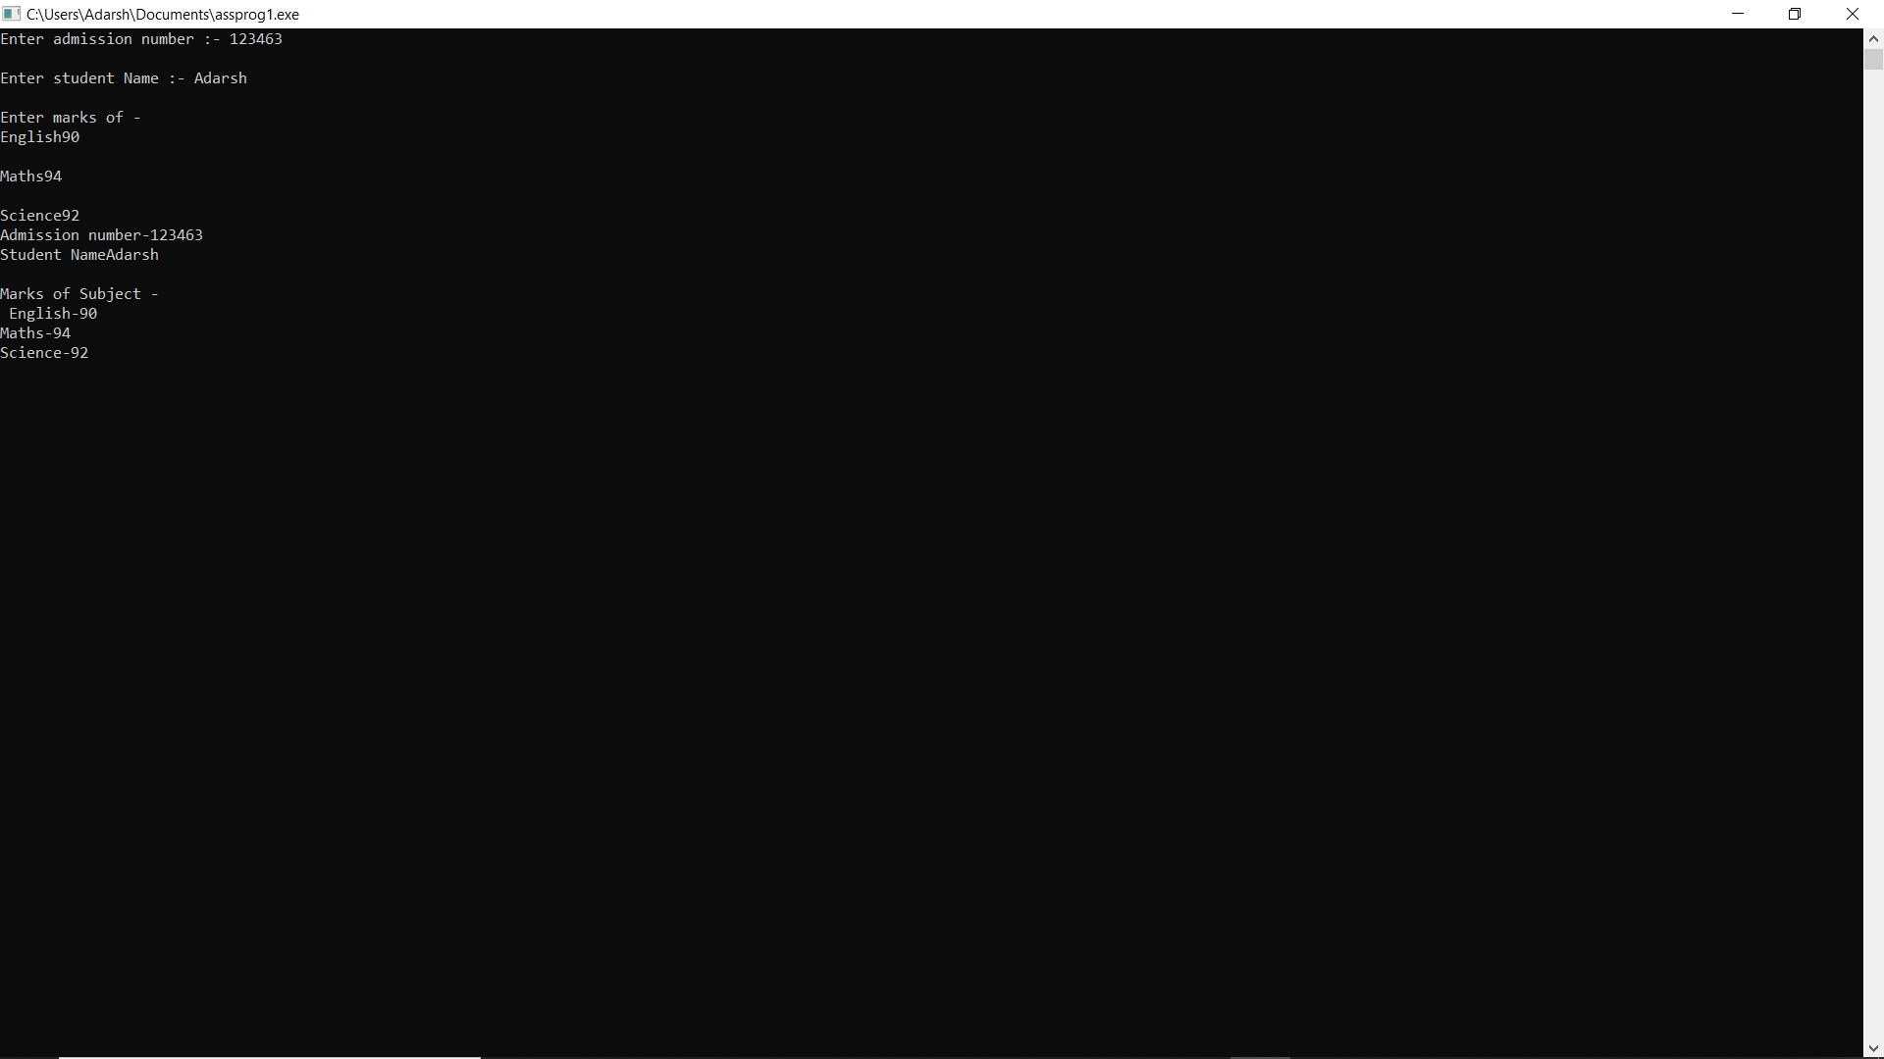

Q2. Define a class batsman with the following specifications:

Private members:

bcode                            4 digits code number

bname                           20 characters

innings, notout, runs        integer type

batavg                           it is calculated according to the formula –

                                     batavg =runs/(innings-notout)

calcavg()                        Function to compute batavg

Public members:

readdata()                      Function to accept value from bcode, name, innings, notout and invoke

the function                                       calcavg()

displaydata()                   Function to display the data members on the screen.

Answer:-

#include<iostream>

#include<stdio.h>

#include<conio.h>

using namespace std;

class Batsman{

int bcode,innings,notout,runs;

char bname[20];

float bavg,avg;

float calcavg()

{

bavg=runs/(innings-notout);

return bavg;

}

public:

void readdata()

{

cout<<"Enter bcode-";

cin>>bcode;

cout<<"\nEnter bname-";

cin>>bname;

cout<<"\nEnter innings";

cin>>innings;

cout<<"\nEnter notout";

cin>>notout;

cout<<"\nEnter runs";

cin>>runs;

avg=calcavg();

}

void displaydata()

{

cout<<"Bcode-"<<bcode;

cout<<"\nBname-";

cout<<bname;

cout<<"\nInnings-"<<innings;

cout<<"\nNotout-"<<notout;

cout<<"\nRuns-"<<runs;

cout<<"\nAverage-"<<avg;

}

} ;

int main()

{

Batsman b;

b.readdata();

b.displaydata();

return 0;

}

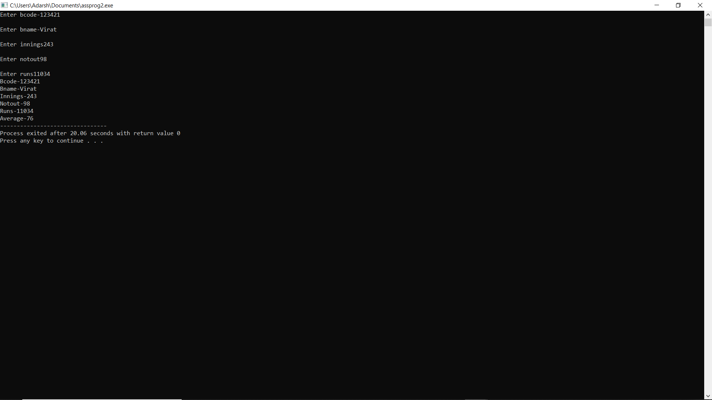

Q3.Define a class TEST in C++ with following description:

Private Members

TestCode of type integer

Description of type string

NoCandidate of type integer

CenterReqd (number of centers required) of type integer

A member function CALCNTR() to calculate and return the number of centers as

(NoCandidates/100+1)

Public Members

-  A function SCHEDULE() to allow user to enter values for TestCode, Description,

NoCandidate &amp; call function CALCNTR() to calculate the number of Centres

- A function DISPTEST() to allow user to view the content of all the data members

Answer:-

#include <iostream>

using namespace std;

class Test

{

int TestCode;

string description;

int NoCandidate, CenterReqd;

int CalCntr()

{

return NoCandidate/100 + 1;

}

public:

void Schedule()

{

cout << "Enter TestCode:: " << endl;

cin >> TestCode;

cout << "Enter Description:: " << endl;

cin >> description;

cout << "Enter NoCandidate:: " << endl;

cin >> NoCandidate;

CenterReqd = CalCntr();

}

void DispTest()

{

cout<< "TestCode:: " << TestCode << endl;

cout<< "Description:: " << description<< endl;

cout<< "NoCandidate:: " << NoCandidate<< endl;

cout<< "Center Required:: " << CenterReqd<< endl;

}

};

int main()

{

Test t;

t.Schedule();

t.DispTest();

return 0;

}

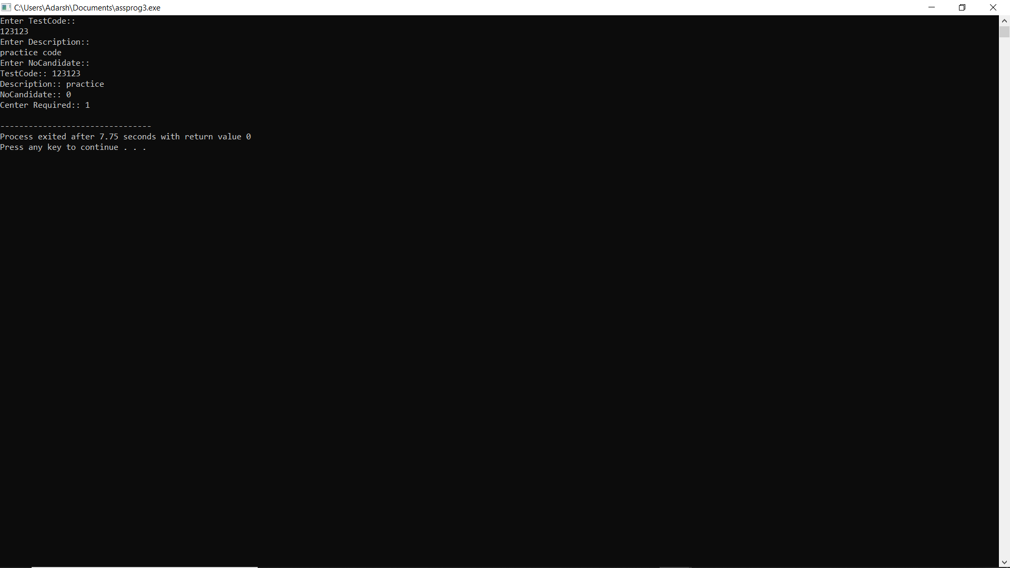

Q4.Define a class in C++ with following description:

Private Members

A data member Flight number of type integer

A data member Destination of type string

A data member Distance of type float

A data member Fuel of type float

A member function CALFUEL() to calculate the value of Fuel as per the following criteria

            Distance                                                          Fuel

            &lt;=1000                                                           500

            more than 1000  and &lt;=2000                          1100

            more than 2000                                              2200

Public Members

A function FEEDINFO() to allow user to enter values for Flight Number, Destination, Distance

&amp; call function CALFUEL() to calculate the quantity of Fuel

A function SHOWINFO() to allow user to view the content of all the data members

Answer:-

#include <iostream>

#include<stdio.h>

using namespace std;

class Cost{

int fno;

float distance,fuel;

char designation[20];

float calcfuel(){

float f;

if(distance<=1000)

{

f=500;

return f;

}

else if(distance>1000&&distance<=2000)

{

f=1100;

return f;

}

else if(distance>2000)

{

f=2200;

return f;

}

else

{

return -1;

}

}

public:

void feedinfo();

void showinfo();

};

void Cost::feedinfo()

{

cout<<"Enter flight number-";

cin>>fno;

cout<<"\nEnter distance-";

cin>>distance;

cout<<"\nEnter designation";

cin>>designation;

fuel=calcfuel();

}

void Cost::showinfo()

{

cout<<fno<<endl<<distance<<endl<<fuel;

cout<<designation;

}

int main()

{

Cost c;

c.feedinfo();

c.showinfo();

return 0;

}

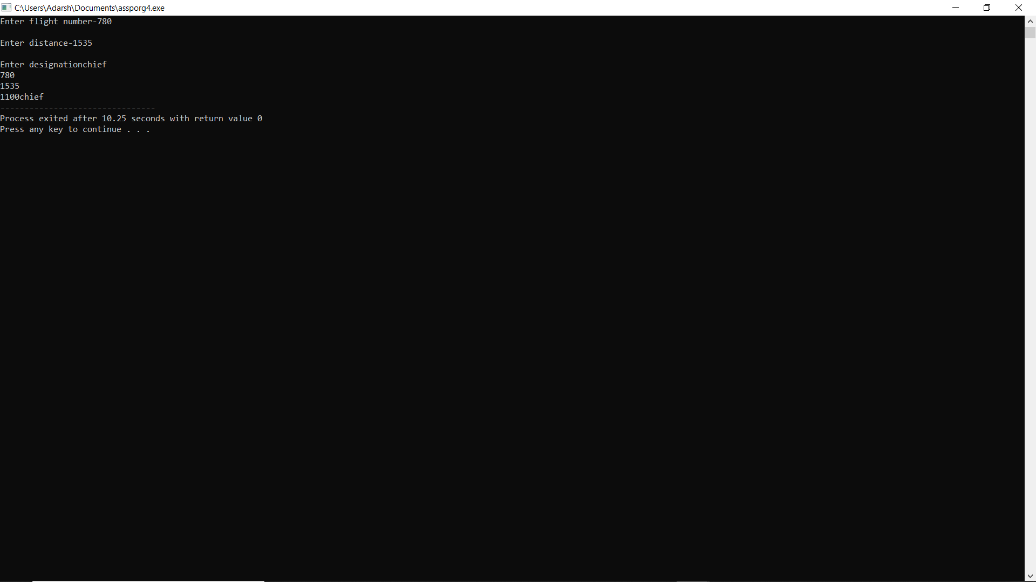

Q5.Define a class BOOK with the following specifications :

Private members of the class BOOK are

BOOK NO                integer type

BOOKTITLE             20 characters

PRICE                     float (price per copy)

TOTAL_COST()        A function to calculate the total cost for N number of copies where N is

passed to the function as argument.

Public members of the class BOOK are

INPUT()                   function to read BOOK_NO. BOOKTITLE, PRICE

PURCHASE()            function to ask the user to input the number of copies to be purchased. It

invokes TOTAL_COST() and prints the total cost to be paid by the user.

Note : You are also required to give detailed function definitions.

Answer:-

#include <iostream>

#include<stdio.h>

using namespace std;

class Book{

int bookno,n;

char booktitle[20];

float price;

public:

void input()

{

cout<<"Enter book number";

cin>>bookno;

cout<<"Enter book price";

cin>>price;

cout<<"Enter book title";

cin>>booktitle;

}

void purchase()

{

float cost;

cout<<"Enter number of copies-";

cin>>n;

cost=total_cost();

cout<<"total cost"<< cost;

}

float total_cost()

{

float t;

t=price*n;

return t;

}

};

int main()

{

Book b;

b.input();

b.purchase();

return 0;

}

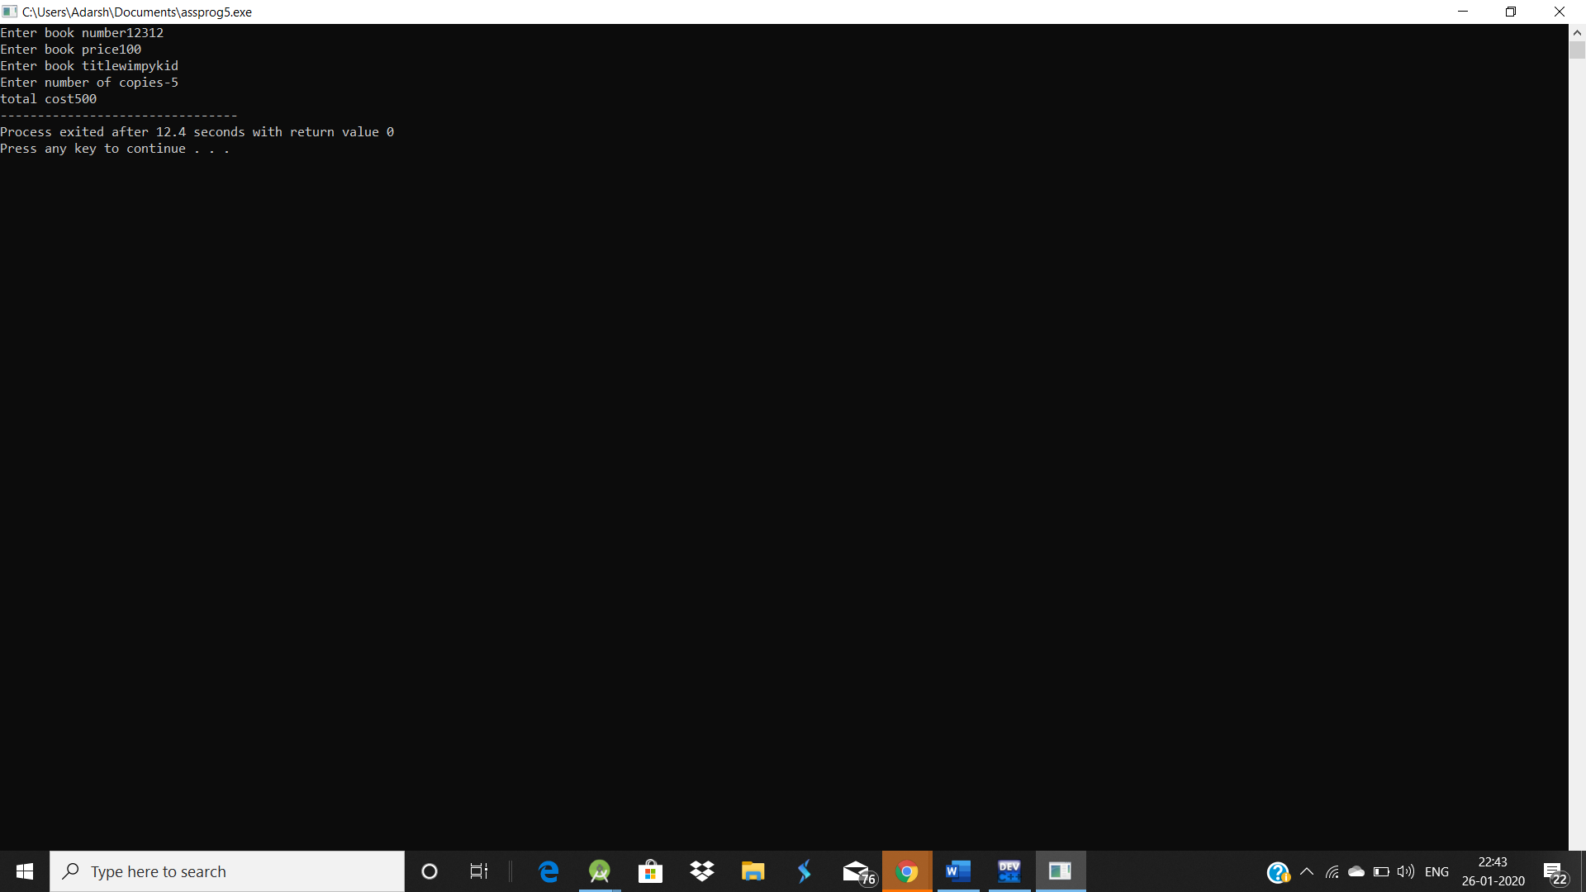

Q6.

#include <iostream>

#include<stdio.h>

using namespace std;

class Report{

int adno;

float marks[5],average;

char name[20];

float getavg()

{

int i;

float avg,s=0;

for(i=0;i<5;i++)

{

s=s+marks[i];

}

avg=s/5;

return avg;

}

public:

void readinfo()

{

int j;

cout<<"Enter admin number-";

cin>>adno;

cout<<"\nEnter name";

cin>>name;

cout<<"\nEnter marks-";

for(j=0;j<5;j++)

{

cin>>marks[j];

}

average=getavg();

}

void display_info(){

int a=0;

cout<<adno<<endl;

cout<<name<<endl;

for(a=0;a<5;a++){

cout<<marks[a]<<endl;

}

cout<<average;

}

};

int main()

{

Report r;

r.readinfo();

r.display_info();

return 0;

}

